 | 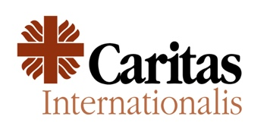 | 

Joint Appeal

Mr. President,

New Humanity (NH), Caritas Internationalis, and the co-signing NGO’s are deeply concerned by the recent escalating violence in Syria’s coastal area since 6 March.

The population has been suffering for more than a decade the terrible consequences of the war, with entire generations growing up knowing only persecution, death and destruction.

We call on the transitional government to guarantee the protection of human rights for all minorities. Promoting unity and inclusivity and respecting the right of freedom of religion is key to ensuring the cohesion of the population, avoiding greater polarization or sectarianism, and achieving lasting peace and stability, both in Syria and in the entire region.

Amidst significant global aid cuts, we welcome the IX Brussels’ donors Conference on Syria. We strongly urge the international community to renew its commitment to deliver long-term, sustainable solutions and financial support, while ensuring effective protection of human rights for individuals, regardless of their religious beliefs.

We also call on the international community to ensure the safe, sustainable, voluntary and dignified return to Syria of those displaced, alongside comprehensive reconstruction efforts aimed at restoring essential infrastructure enabling affected populations to rebuild their lives.

Finally, we advocate for the immediate lifting of sanctions to facilitate much-needed reconstruction activities.

I Thank you.

